 | American International University- Bangladesh (AIUB)  Faculty of Engineering (EEE)
Course Name: |  | MICROPROCESSOR AND EMBEDDED SYSTEMS |  |  |  |  | Course Code: |  | EEE 4103
Semester: |  | 2023-2024, Spring |  |  |  |  | Sec: |  | F
Lab Instructor: |  | Md Sajid Hossain |  |  |  |  | Group: |  | 06
Experiment No: |  | 01
Experiment Name: |  | The implementation of a traffic control system using microcontrollers.
Submitted by (NAME): |  | AZMINUR RAHMAN |  |  |  | Student ID: |  |  | 22-46588-1
Group Members |  |  |  |  | ID |  |  | Name
 |  |  |  | 1. | 22-46588-1 |  |  | AZMINUR RAHMAN
 |  |  |  | 2. | 22-46444-1 |  |  | TRIDIB SARKAR
 |  |  |  | 3. | 19-41203-1 |  |  | MD. IMTIAZ HOSSAIN
 |  |  |  | 4. | 19-40315-1 |  |  | S.M. FAYSAL MAHMUD
 |  |  |  | 5. | 21-45397-3 |  |  | SOWRABH CHANDRA DAS
 |  |  |  | 6. | 21-45489-3 |  |  | AVISHEK CHANDA PRATYAY
 |  |  |  | 7. | 21-45408-3 |  |  | KOWSHIK HALDER
Performance Date: |  |  | January 24, 2024 |  |  | Due Date: |  |  |  | January 31, 2024
Marking Rubrics (to be filled by Lab Instructor)
Category | Proficient  [6] | Good  [4] | Acceptable  [2] | Unacceptable [1] | Secured Marks
Theoretical Background, Methods  & procedures sections | All information, measures and variables are provided and explained. | All Information provided that is sufficient, but more explanation is needed. | Most information correct, but some information may be missing or inaccurate. | Much information missing and/or inaccurate.
Results | All of the criteria are met; results are described clearly and accurately; | Most criteria are met, but there may be some lack of clarity and/or incorrect information. | Experimental results don’t match exactly with the theoretical values and/or analysis is unclear. | Experimental results are missing or incorrect;
Discussion | Demonstrates thorough and sophisticated understanding. Conclusions drawn are appropriate for analyses; | Hypotheses are clearly stated, but some concluding statements not supported by data or data not well integrated. | Some hypotheses missing or misstated; conclusions not supported by data. | Conclusions don’t match hypotheses, not supported by data; no integration of data from different sources.
General formatting | Title page, placement of figures and figure captions, and other formatting issues all correct. | Minor errors in formatting. | Major errors and/or missing information. | Not proper style in text.
Writing & organization | Writing is strong and easy to understand; ideas are fully elaborated and connected; effective transitions between sentences; no typographic, spelling, or grammatical errors. | Writing is clear and easy to understand; ideas are connected; effective transitions between sentences; minor typographic, spelling, or grammatical errors. | Most of the required criteria are met, but some lack of clarity, typographic, spelling, or grammatical errors are present. | Very unclear, many errors.
Comments: |  |  |  | Total Marks  (Out of ):

Title: Familiarization with a microcontroller, the study of blink test and implementation of a traffic control system using microcontrollers.

Abstract:

This experiment focuses on familiarization with microcontrollers, specifically the Arduino platform, and aims to provide hands-on experience in programming and implementing basic electronic projects. The primary objective is to introduce participants to the basics of microcontroller functionality, starting with the blink test using LEDs and Arduino. The experiment progresses to the practical application of this knowledge by implementing a traffic control system using Arduino.

Introduction:

The objective of this experiment are as follows:
- To get familiarized with Microcontroller (ATMega328P, ATmega2560, etc.).
- To familiarize with the application of pinMode();, digitalWrite(); and delay();.
- To develop the LED blink using Arduino and the delay functions.
- To implement a traffic control system using Arduino.

Theory and Methodology:

The open-source platform Arduino is employed for the generation of interactive electronics projects. It comprises a programmable microcontroller and accompanying software, known as the Integrated Development Environment (IDE), which operates on a computer. This IDE serves the purpose of composing and transferring computer code to the microcontroller board. Notably, the Arduino Uno variant eliminates the necessity for an external hardware circuit, commonly referred to as a programmer or burner, to introduce new code into the board. Instead, a straightforward process is facilitated by employing a USB cable and the Arduino IDE, which employs a simplified version of the C++ programming language for code composition.

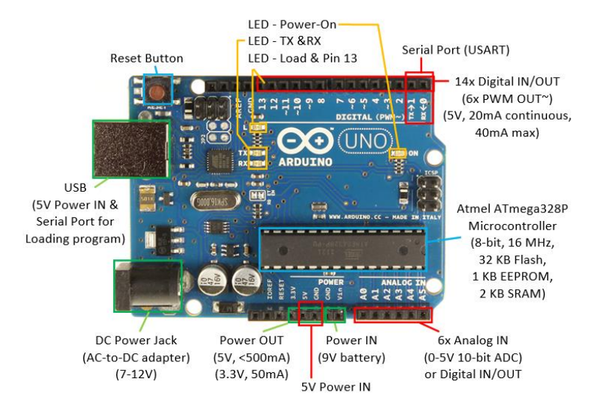
Figure 1: Overview of Arduino Board [1].
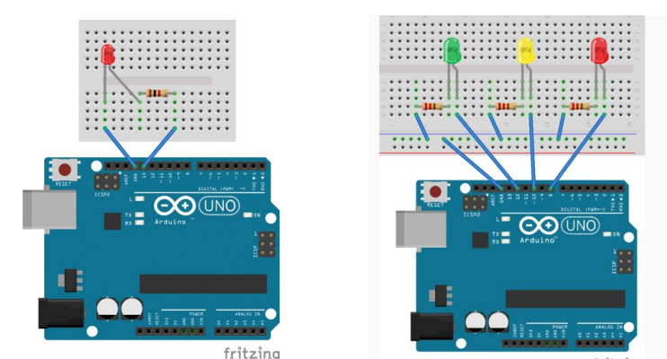

Figure 2: Simulation setup for blink test and traffic control system [1].

Apparatus:

- Arduino IDE (any version).
- Arduino Uno (R3) board or Arduino mega 2560 board.
- LED lights (RED, GREEN, and YELLOW) and three 200 ohms resistors and jumper wires.

Precautions:

- Safety precautions were observed during the experiment, including the proper handling of electronic components and materials to prevent accidents or damage.
- Wiring and connections were carefully attended to prevent short circuits or incorrect wiring.
- Simulations were run in wokwi.com online software to validate the circuits and code before physical implementation to reduce the risk of errors.
- Power sources were disconnected when changes were made to the circuit.

Experimental Procedure:

- The circuit was constructed for the traffic control system with LEDs, and an Arduino board.
- Connect the Arduino board to a PC using a USB cable.
- The code was written for the traffic control system. Ensured that the code used the delay(); function for the time delay.
- In the Arduino IDE, the Arduino board was set up, and the code was written.
- The code was uploaded to the Arduino board, and the expected output was achieved.
- The hardware setup was verified to ensure that the expected output, in terms of LED.
Simulation and Measurement:

Blink Test:

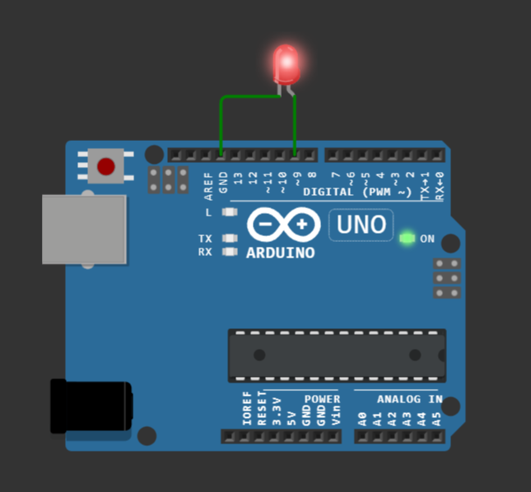
Figure 3: Simulation of Blink Test [2].
Traffic Light Control System:
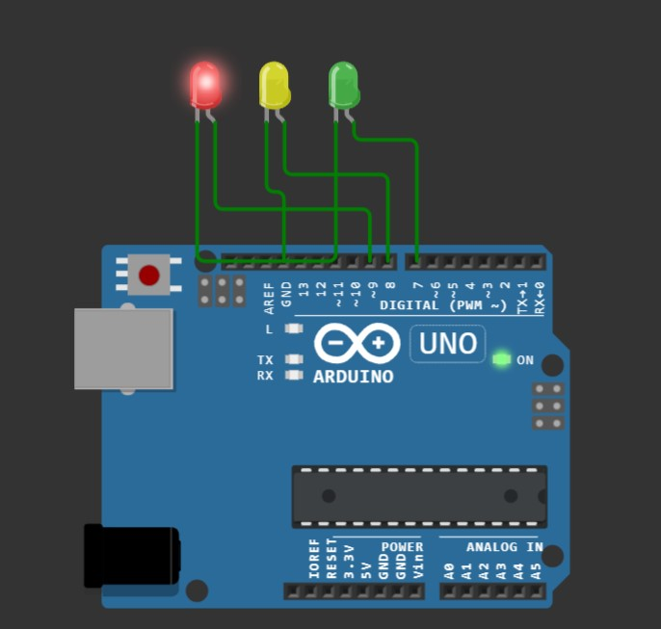  Figure 4: Simulation of Red LED is On [3]. | 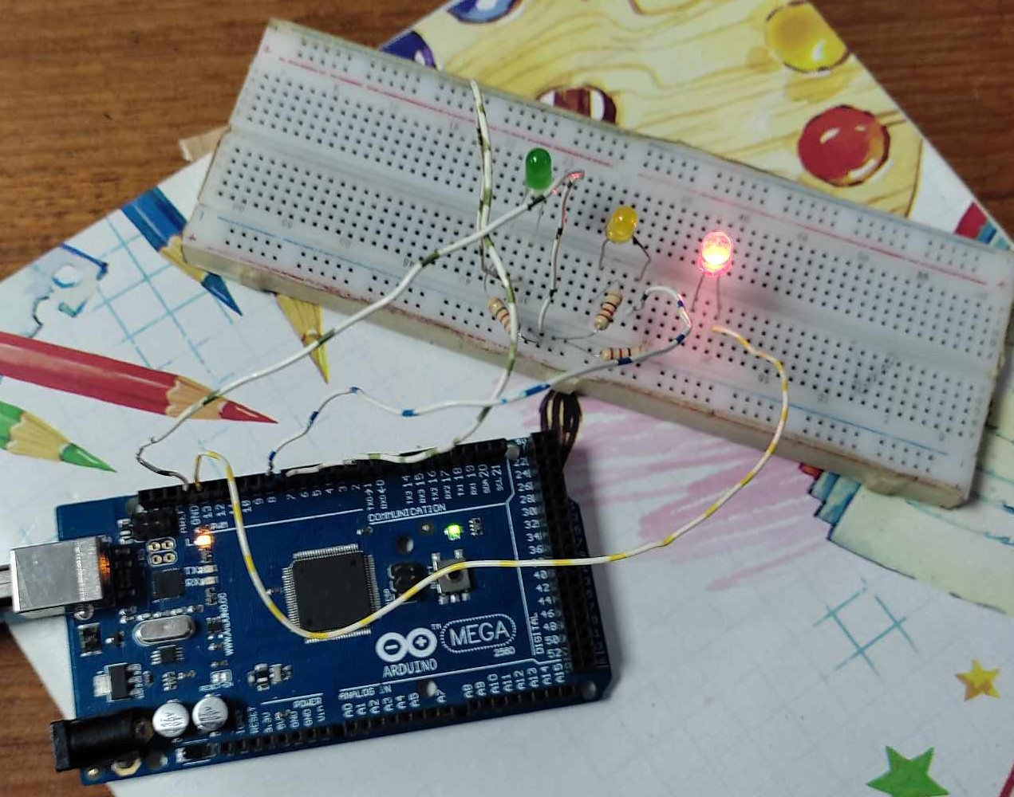  Figure 5: Image of Red LED is On.
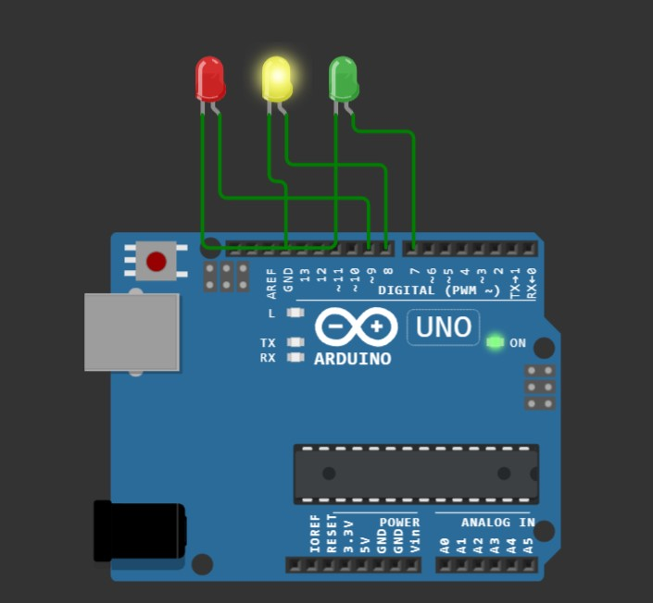  Figure 6: Simulation of Yellow LED is On [3]. | 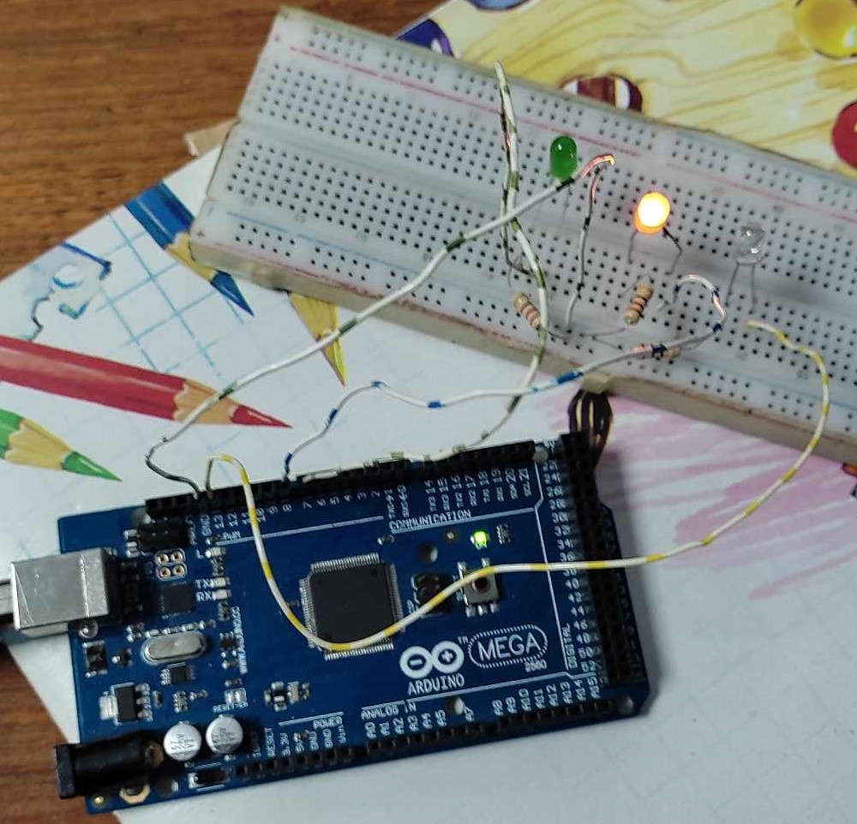  Figure 7: Image of Yellow LED is On.
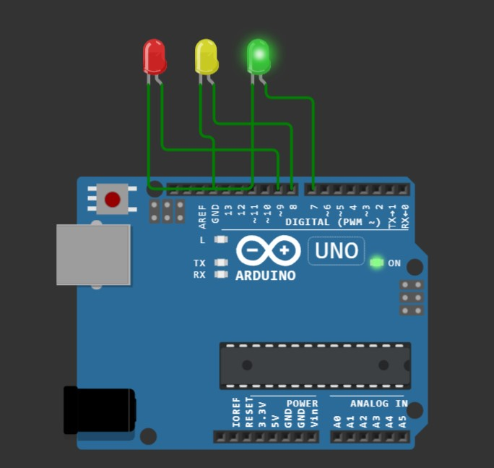  Figure 8: Simulation of Green LED is On [3]. | 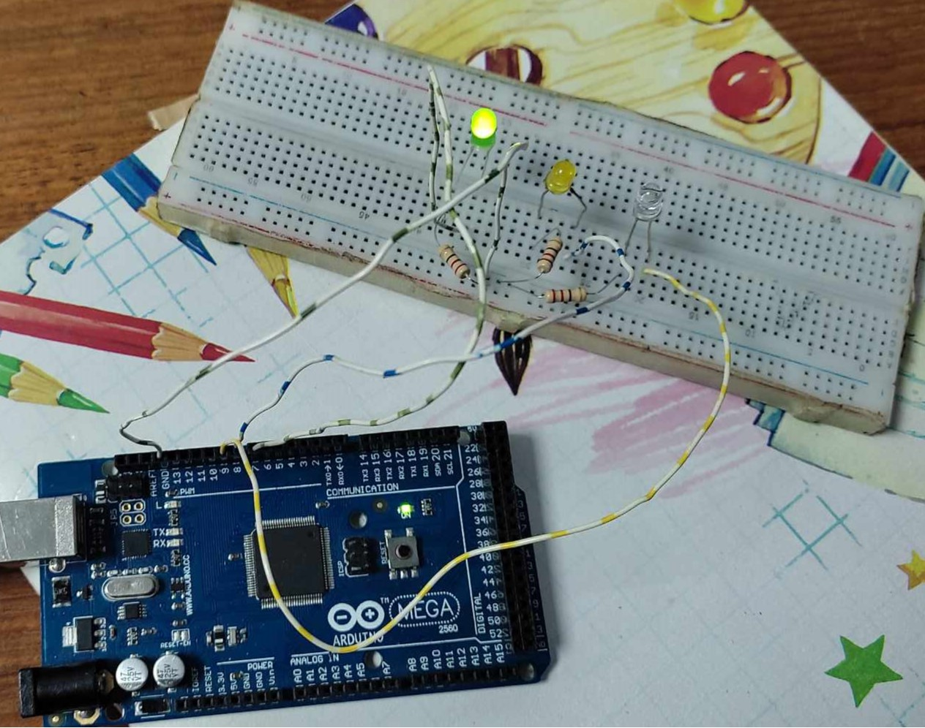  Figure 9: Image of Green LED is On.

Code snippet for the System:

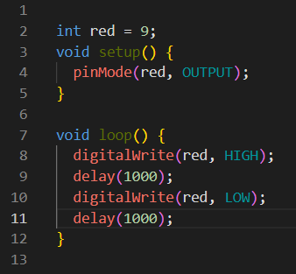

Figure 10: Code snippet for Blink Test [2].

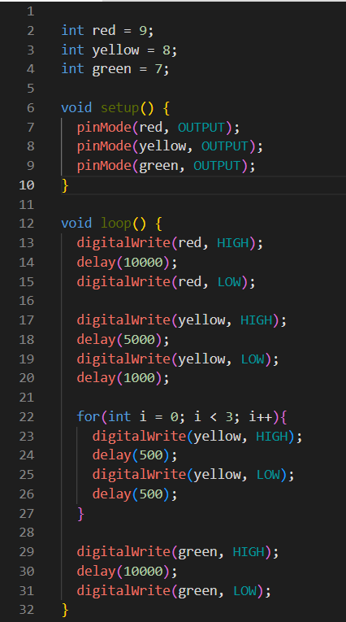

Figure 11: Code snippet for the Traffic Control System [3].

Results/Finding(s):

- All code snippets were provided.
- WOKWI online simulation was included in the simulation, complete with detailed views

Discussion:

The experiment's objectives were successfully achieved as participants were provided with a comprehensive introduction to microcontrollers, specifically focusing on the Arduino platform. Proficiency in fundamental microcontroller functions, such as pinMode();, digitalWrite(); and delay(); was attained through the utilization of Arduino Uno or Mega 2560 boards. The practical application of the blink test using LEDs enabled participants to program and execute LED blinking effectively. The primary emphasis on implementing a traffic control system highlighted the real-world application of acquired skills. Circuit setup, code composition, and the precise timing of LEDs using delay(); were underscored in the discussion. Including WOKWI online simulations as a precautionary measure added a layer of validation to the experiment, ensuring consistency between simulated and physical outcomes. The traffic control system's code snippet was presented clearly and well-documented, contributing to a successful learning experience. Overall, a holistic understanding of microcontrollers was demonstrated in the experiment, encompassing theoretical knowledge, practical implementation, and the incorporation of online simulations for a well-rounded educational experience.

Conclusions:

In conclusion, this experiment successfully achieved its objectives by providing participants with a comprehensive understanding of microcontrollers, hands-on experience in programming with Arduino, and practical application through the implementation of a traffic control system. The combination of theoretical concepts, experimental procedures, and online simulations contributed to a well-rounded learning experience for the participants.

Reference(s):

- Lab Manual. Available: http://tinyurl.com/maes-exp1, Accessed on 31-Jan-24. [Online].

- WOKWI (Blink Test). Available: https://wokwi.com/projects/388452733826522113, Accessed on 31-Jan-24. [Online].

- WOKWI (Traffic Light Control Syst). Available: https://wokwi.com/projects/388276482095077377, Accessed on 31-Jan-24. [Online].

- Arduino, "Arduino - Home," Available: https://www.arduino.cc, Accessed On: 31-Jan-24. [Online].

- J. Blum, "Exploring Arduino: Tools and Techniques for Engineering Wizardry," 1st ed. Indianapolis, IN: Wiley, 2013, ISBN: 978-1118549360.

